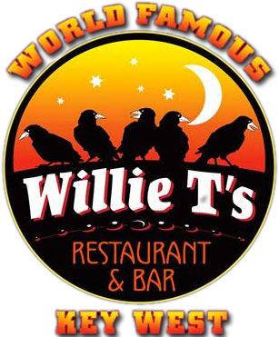
Patriots Lunch Menu
Served daily from 11 am – 2 pm for all Uniformed Coast Guard Members and their immediate families during Government Shutdown

Willie T’s House Salad
Mixed Greens, Cherry Tomatoes, Carrots, Cucumber, Pepperoncinis, Red Onion, Herbed Croutons and topped with Feta Cheese. Served with Blackened, Grilled or Fried Chicken Breast.
Classic Burger*
Our World Famous 2/3 Pound Black Angus Burger Charbroiled topped with Sharp Cheddar Cheese, Lettuce and Tomato on a Sesame Roll. Served with Fries.

Turkey Club Sandwich
Smoked Turkey, Applewood Bacon, Swiss Cheese, Lettuce, Tomato and Mayo on Choice of Sour Dough or Whole Wheat Bread. Served with Fries.

Penne Marinara
Penne Pasta served with a Fresh Roasted Chunky Tomato-Basil Sauce with Roasted Garlic, Oven Roasted Tomatoes and Topped with Fresh Grated Parmesan Cheese. Served with Blackened, Grilled or Fried Chicken Breast.

Chicken Quesadilla
Chicken Breast, Cheddar and Jack Cheese Sautéed Onions and Bell Peppers served with Homemade Guacamole, Salsa and Sour Cream.

Chicken Tenders with Fries

Macaroni and Cheese

Full Kids’ Menu Available

Soda, Juice, Lemonade or Coffee

*Consumer Advisory: Consuming raw or undercooked meat, eggs, poultry or seafood increases your risk of contracting a food borne illness – especially if you have certain medical conditions. Section 3-603.11 2001 FDA Food Code.

